# DECLARATION BY THE CANDIDATE(s)

We, the undersigned solemnly declare that the report of the project work entitled *Money Manager*, is based on my own work carried out during the course of my study under the guidance of *Prof.* *Monika Verma.*

We assert that the statements made and conclusions drawn are an outcome of the project work. We further declare that to the best of my knowledge and belief that the report does not contain any part of any work which has been submitted for the award of any other degree/diploma/certificate in this University/deemed University of India or any other country.

Ankur Cyrus Tirkey Devansh Shrivastava Devdeep Goyal Nilay Sahu

|  |  |  |  |
| --- | --- | --- | --- |
| Roll No.:300102221052 | Roll No.:300102221033 | Roll No.:300102221053 | Roll No.:300102221065 |
| Enrollment No.:CA6447 | Enrollment No.:CA6480 | Enrollment No.: CA6449 | Enrollment No.: CA6423 |

Prof. Monika Verma

Assistant Professor

Computer Science and Engineering

# CERTIFICATE OF THE SUPERVISOR

This is to certify that the report of the project entitled *Money Manager* is a record of Bonafede research work carried out by

|  |  |  |
| --- | --- | --- |
| Ankur Cyrus Tirkey | Enrollment No.: CA6447 | Roll No.: 300102221052 |
| Devansh Shrivastava | Enrollment No.: CA6480 | Roll No.: 300102221033 |
| Devdeep Goyal | Enrollment No.: CA6449 | Roll No.: 300102221053 |
| Nilay Sahu | Enrollment No.: CA6423 | Roll No.: 300102221065 |

under my guidance and supervision for the award of Mini Project-1 of 3rd Semester of Bachelor of Technology in Computer Science and Engineering, Bhilai Institute of Technology, Durg, an autonomous institute affiliated to Chhattisgarh Swami Vivekanand Technical University, Bhilai

(CG).

To the best of my knowledge and belief the project

1. Embodies the work of the candidate him/herself,
2. Has duly been completed,
3. Fulfills the requirement of the Ordinance relating to the B.Tech. degree of the University and
4. Is up to the desired standard for the purpose of which is submitted.

Prof. Monika Verma

Assistant Professor Computer Sc. And Eng.

The Project work as mentioned above is hereby being recommended and forwarded for examination and evaluation.

Dr.(Mrs.) Sunita Soni

Head Of the Department

Computer Sc. And Eng.

# CERTIFICATE BY THE EXAMINERS

Submitted by

|  |  |  |
| --- | --- | --- |
| Ankur Cyrus Tirkey | Enrollment No.: CA6447 | Roll No.: 300102221052 |
| Devansh Shrivastava | Enrollment No.: CA6480 | Roll No.: 300102221033 |
| Devdeep Goyal | Enrollment No.: CA6449 | Roll No.: 300102221053 |
| Nilay Sahu | Enrollment No.: CA6423 | Roll No.: 300102221065 |

Has been examined by the undersigned as part of the examination and is hereby recommended for

the Mini Project-I of 3rd semester of Bachelor of Technology in Computer Science and Engineering,

Bhilai Institute of Technology, Durg, an autonomous institute affiliated to Chattisgarh Swami Vivekanand Technical University, Bhilai ( CG).

Internal Examiner External Examiner

## Date: Date:

**ACKNOWLEDGEMENT**

I have great pleasure in the submission of this project report entitled **Money Manager** in partial fulfillment the degree of Bachelor of Engineering (CSE). While submitting this Project report, I take this opportunity to thank those directly or indirectly related to project work.

I would like to express sincere thanks and gratitude to **Dr. Mohan Kumar Gupta, Principal of the Institution**, **Dr. (Mrs.) Sunita Soni, Head of the Department** Computer Science & Engineering for their encouragement and cordial support.

While Submission of the project, I also like to thanks to **Prof. Monika Verma and Prof. Kauleshwar Prasad, Project Coordinator,** faculty and all the staff of department of Computer Science & Engineering, **Bhilai Institute of Technology, Durg** for their continuous help and guidance throughout the course of project.

Acknowledgement is due to our parents, family members, friends and all those persons who have helped us directly or indirectly in the successful completion of the project work.

Ankur Cyrus Tirkey Devansh Shrivastava Devdeep Goyal Nilay Sahu

Bhilai Institute of Bhilai Institute of Bhilai Institute of Bhilai Institute of

Technology, Durg Technology, Durg Technology, Durg Technology, Durg

**ABSTRACT**

Mobile application have become a part of day to day life. Many applications are available in the market to manage personal and group expenses. Not many applications are reliable or are able fulfil the user requirements. In this project I have design a website that managers all your expenses, your personal contribution toward group expenses, maintain monthly income, recurring and adhoc payment. It provides information of "who owes who and by how much".

The proposed website would eliminate sticky note, spreadsheet and ledger that cause confusions, data inconsistency problems while recording and splitting of expenses. With our website user can manage these expenses more effectively. This website will not only helps users to manage their expenses but also help marketing executives by providing them the platform they need.

**Content**

Declaration by the candidate i

Certificate of the Supervisor ii

Certificate by the Examiners iii

Acknowledgement iv

Abstract v

List of Tables vi

List of Figures vii

Chapter-1 Introduction 1

* 1. Background Study

Chapter-2 Requirements 2

2.1 Hardware requirements

2.2 Software requirements

Chapter-3 Methodology

3.1 Home Page 3

3.2 Sign-in Page 3

3.3 User Section 4

3.4 Splitting of Bill 4

3.5 History Page 5

Chapter-4 Result 6

Chapter-5 Scope and Future Applications 7

Chapter-7 Advantages 7

Chapter-8 Conclusion 8

References(Website, book)

**1. INTRODUCTION**

Money Manager is a website intended to run on any web browser. It is design to fulfil the needs of the user by reducing their efforts for the settlement of the bill. The website encourages corresponding users help in who owes who, and for what. Aim to provide user the best approach to help user and their companion to share expenses easily.

Our website doesn’t only split money but also track the past records. There is a blog page where many young one’s learned different terminologies of finance and increase their assets. It also helps teenagers to built a path for future investment and control their expenses.

This website will let bunch users and their companions to have detailed view inside this website around the individual costs and settle them.

There is a guest page where people just come without sign-in into the page and split their money very conveniently. With the help of these website teenagers build a habit of managing their pocket money ,which led them in future for building a good asset.

**1.1 Background Study**

The idea of developing this application arises with the frequent problems being faced by the user in sharing among them. Splitting the expenses among group is confusing and maintaining the personal expense is a big deal. There were different methods used before to maintain the expenses like making use of sticky note by normal people, professional people uses spreadsheet to record expenses or by using ledger to maintain huge amounts.

There are still problems in area like data consistency, there are chances were critical inputs can be missed and the manual errors my creep in. The Data recorders are not always handy and it could be hectic process to have overall view of those expenses.

**2. REQUIREMENTS**

**2.1 Hardware requirements**

|  |  |
| --- | --- |
|  | **Windows Requirements** |
| Operating System | Windows 8 or later |
| Processor | Intel Pentium 4 or later |
| Memory | 2 GB minimum, 4 GB recommended |
| Internet connection | Required |
| **Application window** | 1024x680 or larger |
| size |  |

**2.2 Software requirements**

**2.2.1 Software**

Visual Studio code

AMPP

WAMP

**2.2.2 Languages**

**React Js –** React Js is open Source and free Frontend JavaScript library for building user interface based on UI components.

**HTML and CSS -** CSS stands for Cascading Style Sheets.CSS saves a lot of work. It can control the layout of multiple web pages all at once.

**Bootstrap -** Bootstrap is maintained by a [small team of developers](https://github.com/orgs/twbs/people) on GitHub. We’re actively looking to grow this team and would love to hear from you if you’re excited about CSS at scale, writing and maintaining vanilla JavaScript plugins, and improving build tooling processes for frontend code.

**3. METHODOLOGY**

* 1. **Home page or Starting Page**

In this page we take input from user and write the purpose of expenditure and amount in that column.

Then there is Get started button which took us to Sign-in page.

There is also blog page in home page where we provide information about finance related terms some tricks and tips which create interest about management and finance to the user.

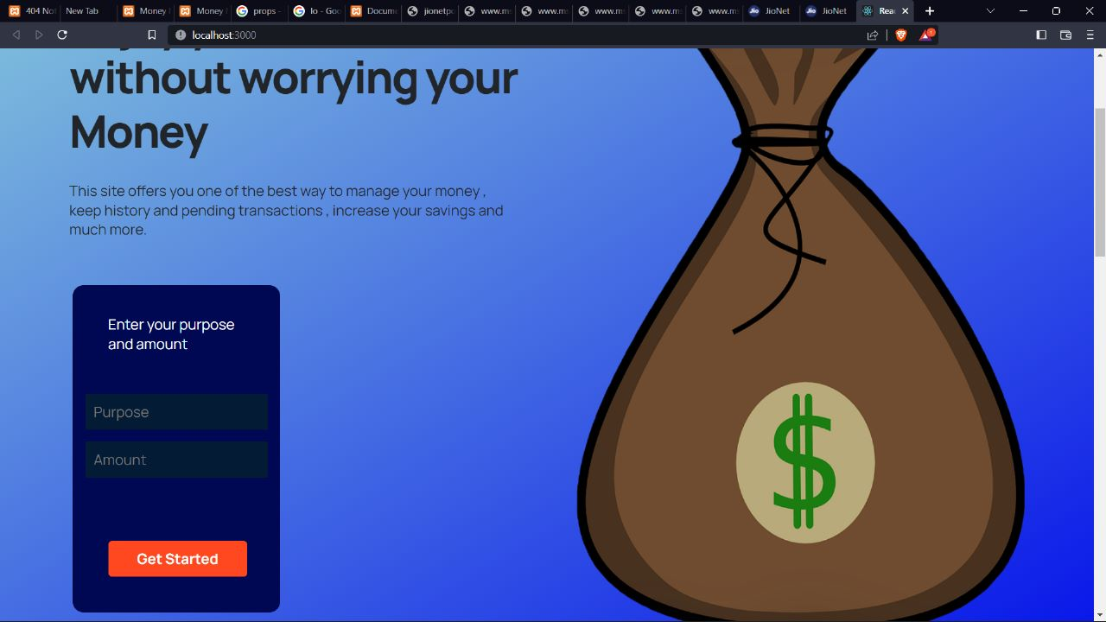

Fig. 3.1 : Home page

* 1. **Sign-in Page**

In this page a user can create a sign-in page where we put username and password .Then input of user is stored.

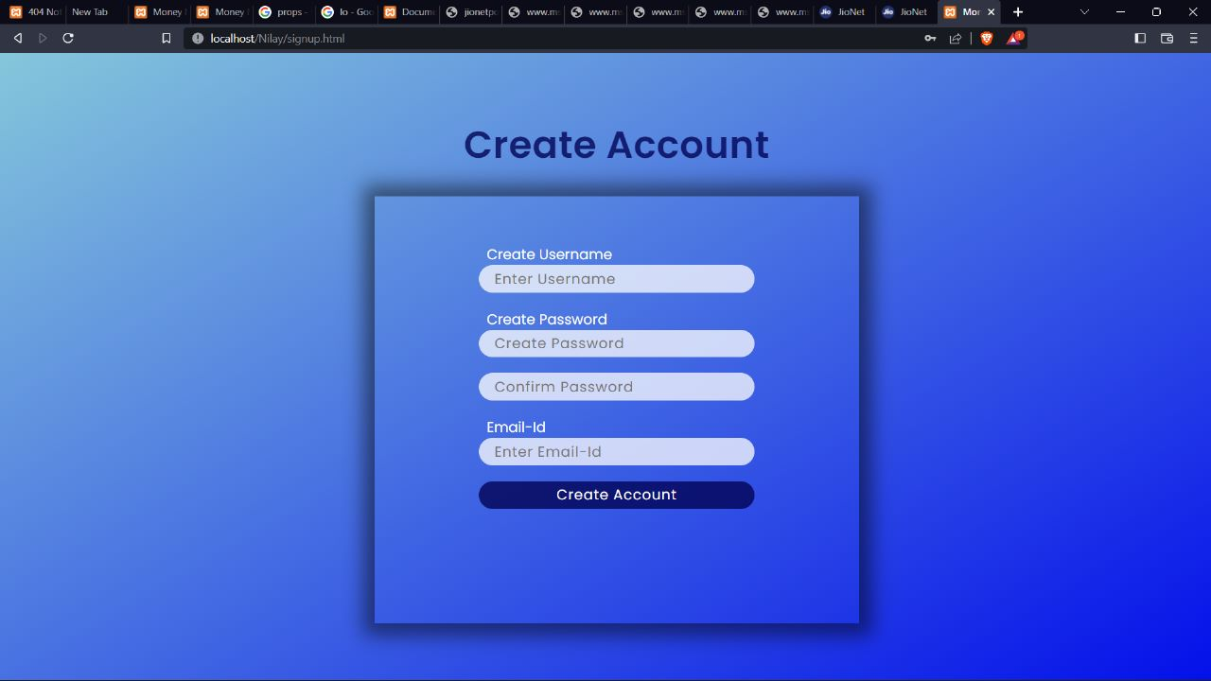

Fig.3.2 : Sign-in Page

* 1. **User Section**

Here we put number of people and amount.

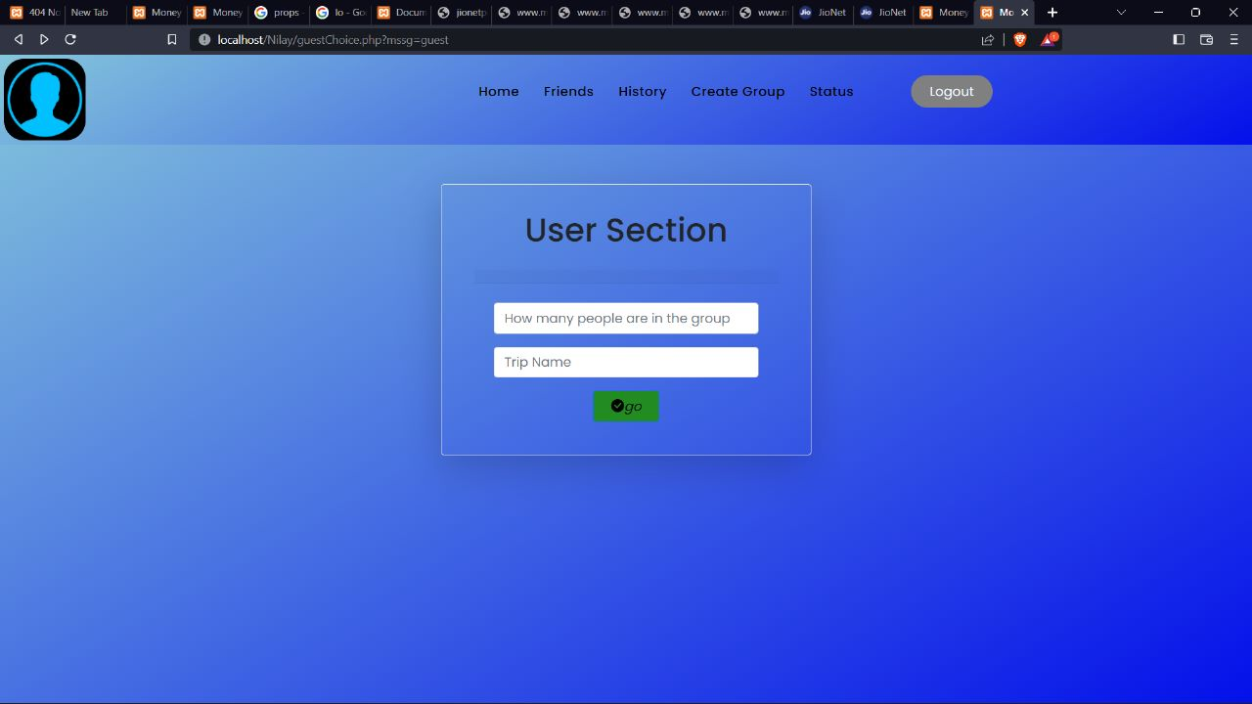

Fig. 3.3 :User Section

* 1. **Splitting of bill**

After taking input bill will be splitted into different user and a output will come will show how has to pay to whom and likewise. All other data will we added into history.

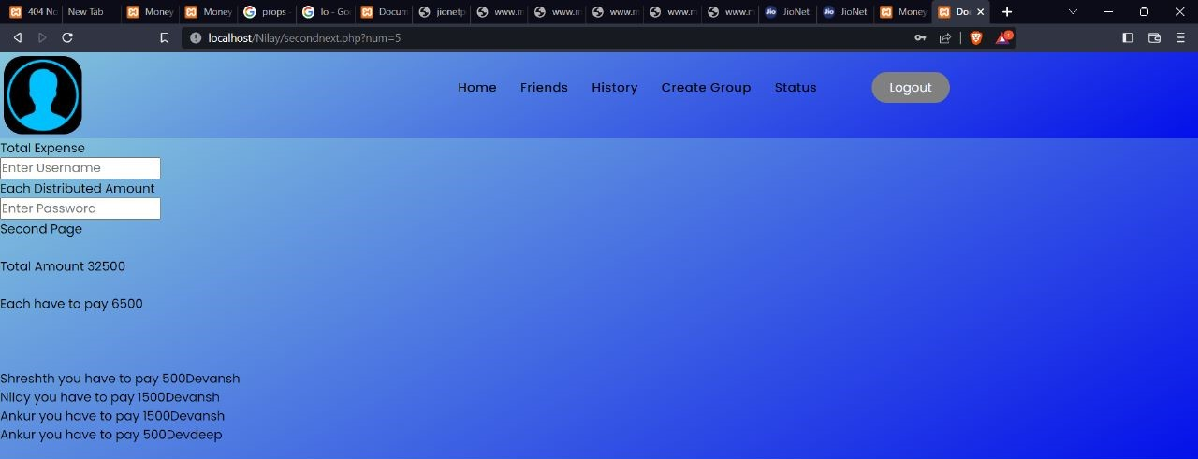

Fig. 3.4 : Splitting page

* 1. **History page**

Here all previous history has been stored and it will give a full detail about who will pay to the user and other persons

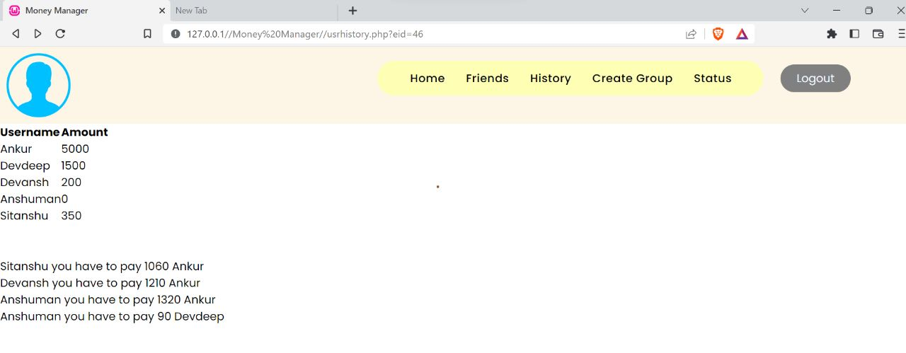

Fig.5

**4. RESULT**

This is how our Money Manager works.

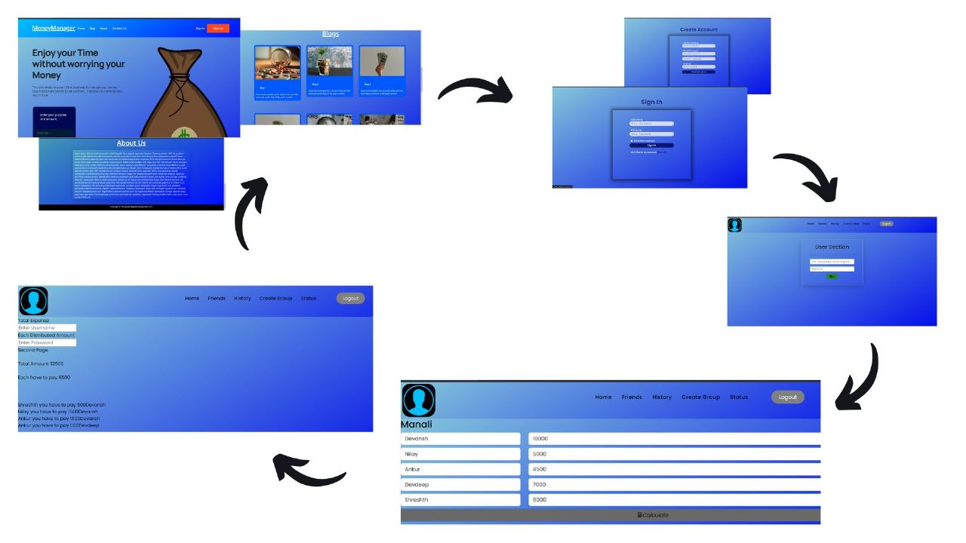

Fig. 4 : Result

**5. SCOPE AND FUTURE APPLICATIONS**

The Scope of the project is that we can modify it by providing a group of people and they can generate a key through which they can interact with each other . We can also join these with Paytm and other banking services and we can put a WhatsApp link at the history page through which we can give message to other people to pay that user.

We can finally make both website and App for this money managing or splitting . we can also add graph which shows the rest of the month expenditure and how to spend it more efficiently.

1. **ADVANTAGES**

* We can easily split our bill among our friends.
* This website give some financial tips and information with the help of blogs.
* We can manage our expenses easily and track a record who will pay to whom.

**7. CONCLUSION**

We have developed this website to help user to track a user personal expense, his/her contribution towards group expenses, maintain monthly income, recurring payments, and to settle all the shares on the spot. It also provides information of “who owes who and by how much”.This website will reduce human efforts for the settlement of the shares. It will also minimize the human interfere in the splitting process which will lead to the most accurate results. The website will eliminate sticky note, spreadsheet and ledger that cause confusions, data inconsistency problems while recording and splitting of expenses.

This website will not only help user to maintain expenses but will also settle the expenses on the spot which could be the hectic process.

**8. REFERENCES**